2/24/2026
RMNP Models for intelimon
- Ponderosa mean canopy base height
- Mixed conifer canopy base height

- Ponderosa mean canopy base height
- Pred: pipo_meanCBH_pred
- Vars: pipo_meanCBH_vars
- n(training) = 36
- n(test) = 4
- lm1 <- lm(formula = train_pred$meanCBH ~ h_zq35 + SDSHT + h_zq15)
- r2 = 0.62, adj. r2 = 0.585, rmse = 1.135
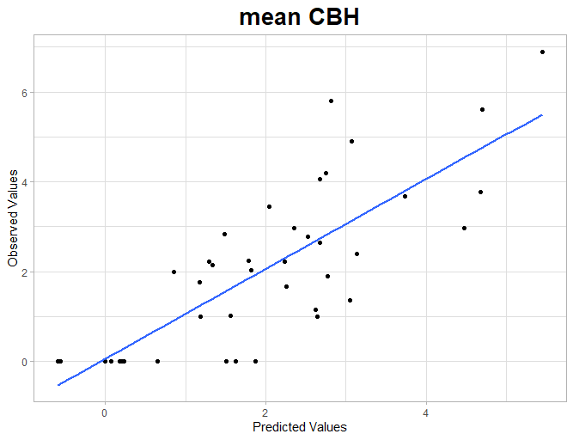
- rmse test = 3.56
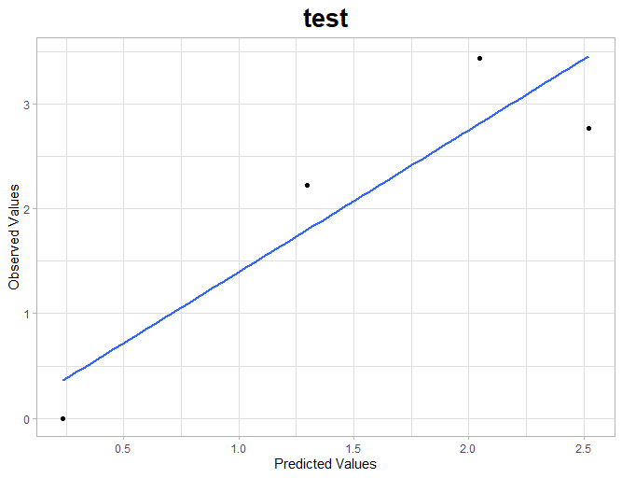

- East Side Total Trees per acre

lm1 <- lm(formula = train_pred$TotalTreesPerAcre ~ h_US_median + StemsPacre)
n(test) = 9
n(training) = 81
r2 = 0.8, adj r2 = 0.799, rmse = 31.46
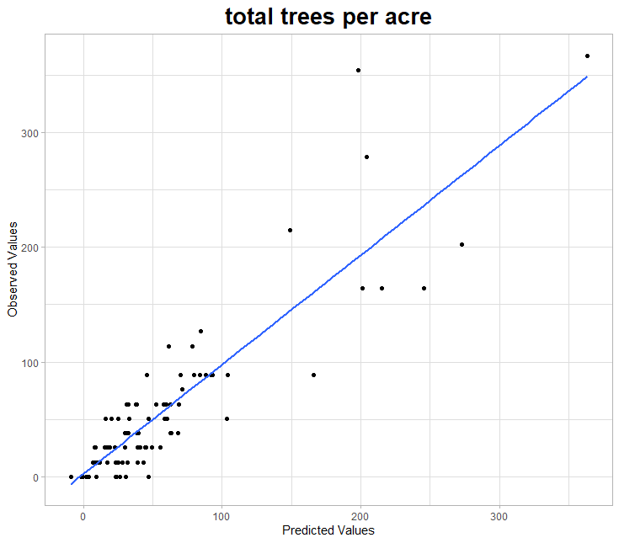

Test rmse = 24.63

